BIT 4107 – Mobile Application Development
ENHANCED PROFESSIONAL STUDENT LOGBOOK
Student Name: wambugu Ian Muturi
Admission Number: BIT/2024/55296
School/Faculty: Mount Kenya University
Program; IT
Academic Year: 2026
Semester: 3RD SEM

Instructions
This logbook is used to document weekly learning activities, practical exercises, skills acquired, challenges encountered, solutions applied, and reflections. Students should complete all sections every week.
Each week to follow remarks in week 1 section.

Autogenerated Table of content
Table of Contents
Instructions 2
Week 1: Introduction to Mobile Application Development 4
Practical Activities Undertaken 4
Tools/Software Used 4
Personal Reflection 5
Week 2: Mobile Development Environment 6
Tools/software used: 7
Personal Reflection 7
Week 3: User Interface Design 7
Tools used: 10
Personal Reflection 10
Week 4: Event Handling and User Interaction 10
Tools used: 12
Personal reflection: 12
Week 5: Data Management 12
Personal reflection: 13
Week 6: Networking and APIs 14
Tools used: 14
ANSWERS TO CLASS WORK………………………………………………………………………………14
Personal reflection: 14
Week 7: Application Architecture 16
Same as week 1 16
Week 8: Project Planning 17
Week 9: Device Features and Sensors 18
Same as week 1 18
Week 10: Notifications and Background Services 19
Same as week 1 19
Week 11: Mobile Security 20
Same as week 1 20
Week 12: Testing and Debugging 20
Same as week 1 20
Week 13: Application Deployment 20
Same as week 1 20
Week 14: Final Project Presentation 20
Same as week 1 20
Semester Project Tracking 21
Project Title 21
Project Objectives 21
Project Requirements 21
Development Milestones 21
Testing Results 21
Lessons Learned 21
Future Improvements 21
End of Semester Reflection 22
Summary of Skills Acquired 22
Most Interesting Topic 22
Major Challenges Faced 22
How Challenges Were Overcome 22
Professional Growth Achieved 22
Overall Course Experience 22
Final Approval 22

Week 1: Introduction to Mobile Application Development

Practical Activities Undertaken
I learnt the various apps for mobile development together with installing the tools

Tools/Software Used
Android studio
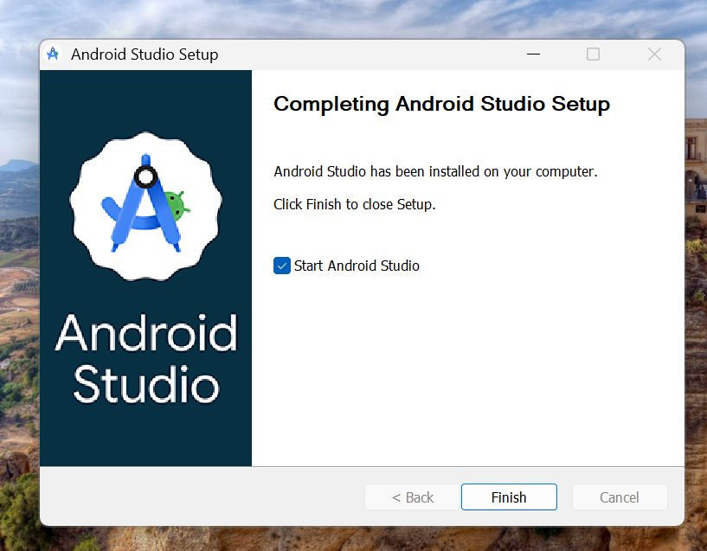

Personal Reflection
I choose to use android studio, I installed A.S as it had more feature to use over other applications.

Week 2: Mobile Development Environment
SDK Setup in android studio
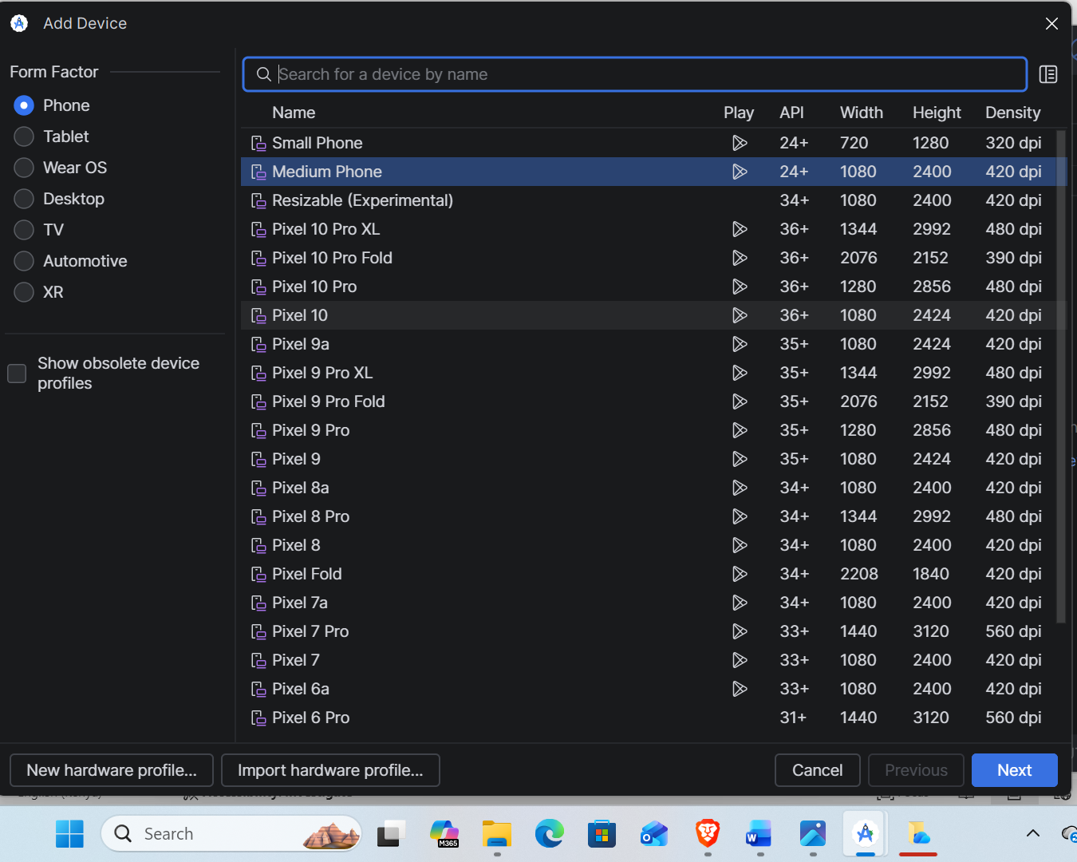

Tools/software used:
Android Studio IDE, Java Development Kit (JDK), Android Virtual Device (AVD) Manager

Personal Reflection
Setting up the SDK for android studio and running the emulator was a good first. But I ran to some trouble running the emulator on my laptop which resulted to me running the code written directly into my phone via cable under developers option why I activated USB debugging.

Week 3: User Interface Design

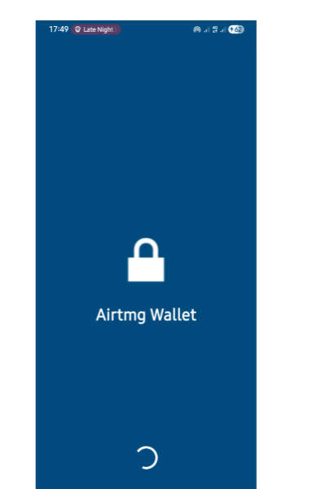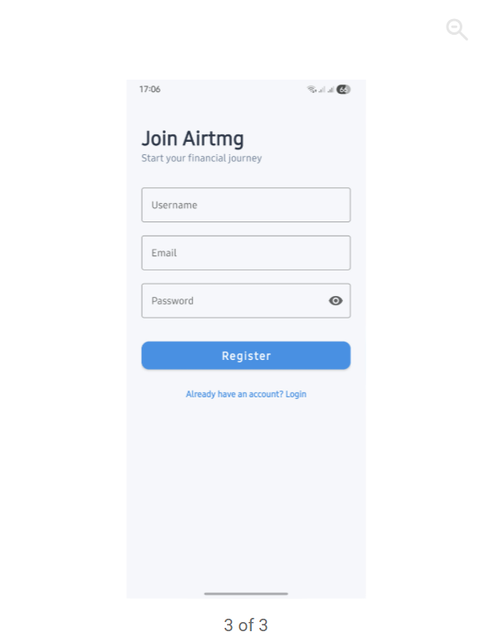

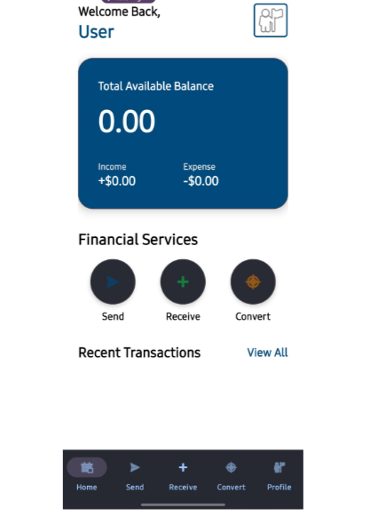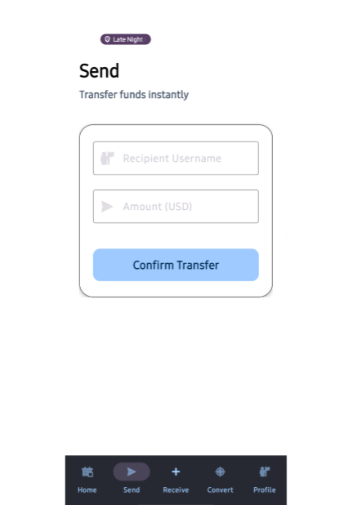
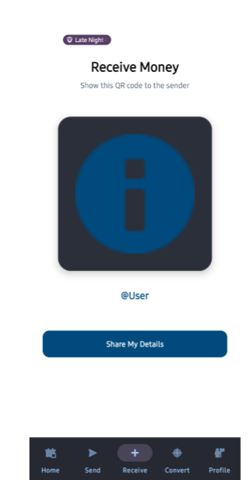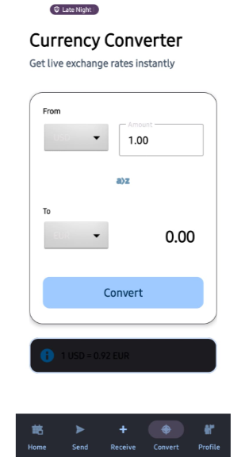

Tools used:
Figma

Personal Reflection
-I learnt how to design my 5 screens of my fund exchange application using figma and i was able to create a dashboard where the owner can view account balances and a navigation flow from one screen to another according to the user flow.

Week 4: Event Handling and User Interaction
On the user interaction will provide screenshots of one of the example of how the app handles events
Step1
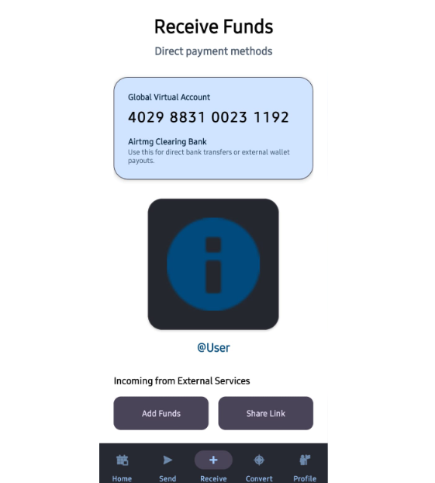
Step 2 : Pressing the add funds button
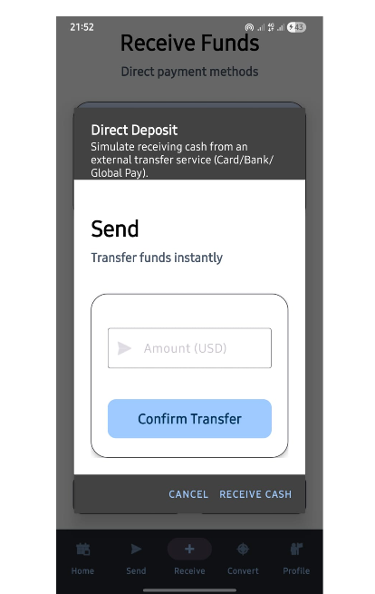

Tools used:
-Android studio
-Java

Personal reflection:
I learnt how to make apps interactive using event handling. I used buttons, text input, navigation bars, communication dialogs and error handling where wrong input result to a pop up messages. This combination of event handling and user interaction make my application responsive intuitive and user friendly.

Week 5: Data Management
Using a transaction transfer to explain how my application manages data:
1)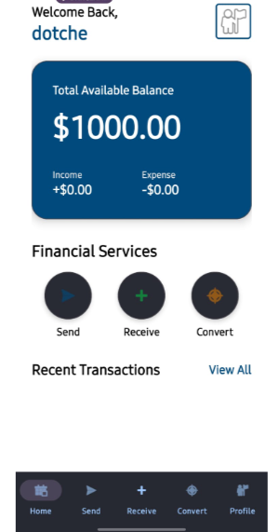 2)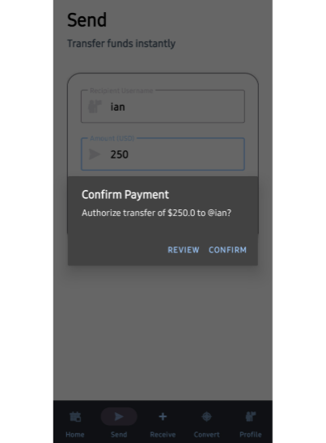 3)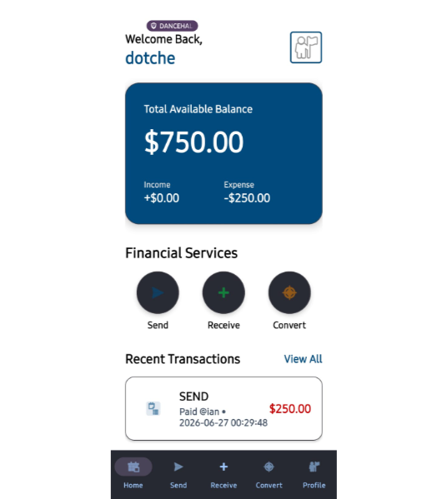
A record of a successful transaction

4)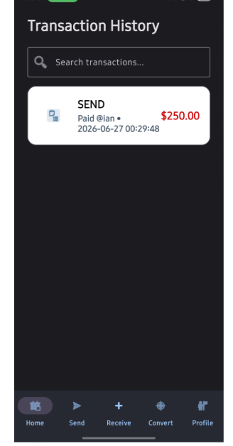
This is where all history of all complete transactions are recorded

Tools used:
-Android studio
-Java

Personal reflection:
I learnt how to store and record data in my application using android studio.

Week 6: Networking and APIs
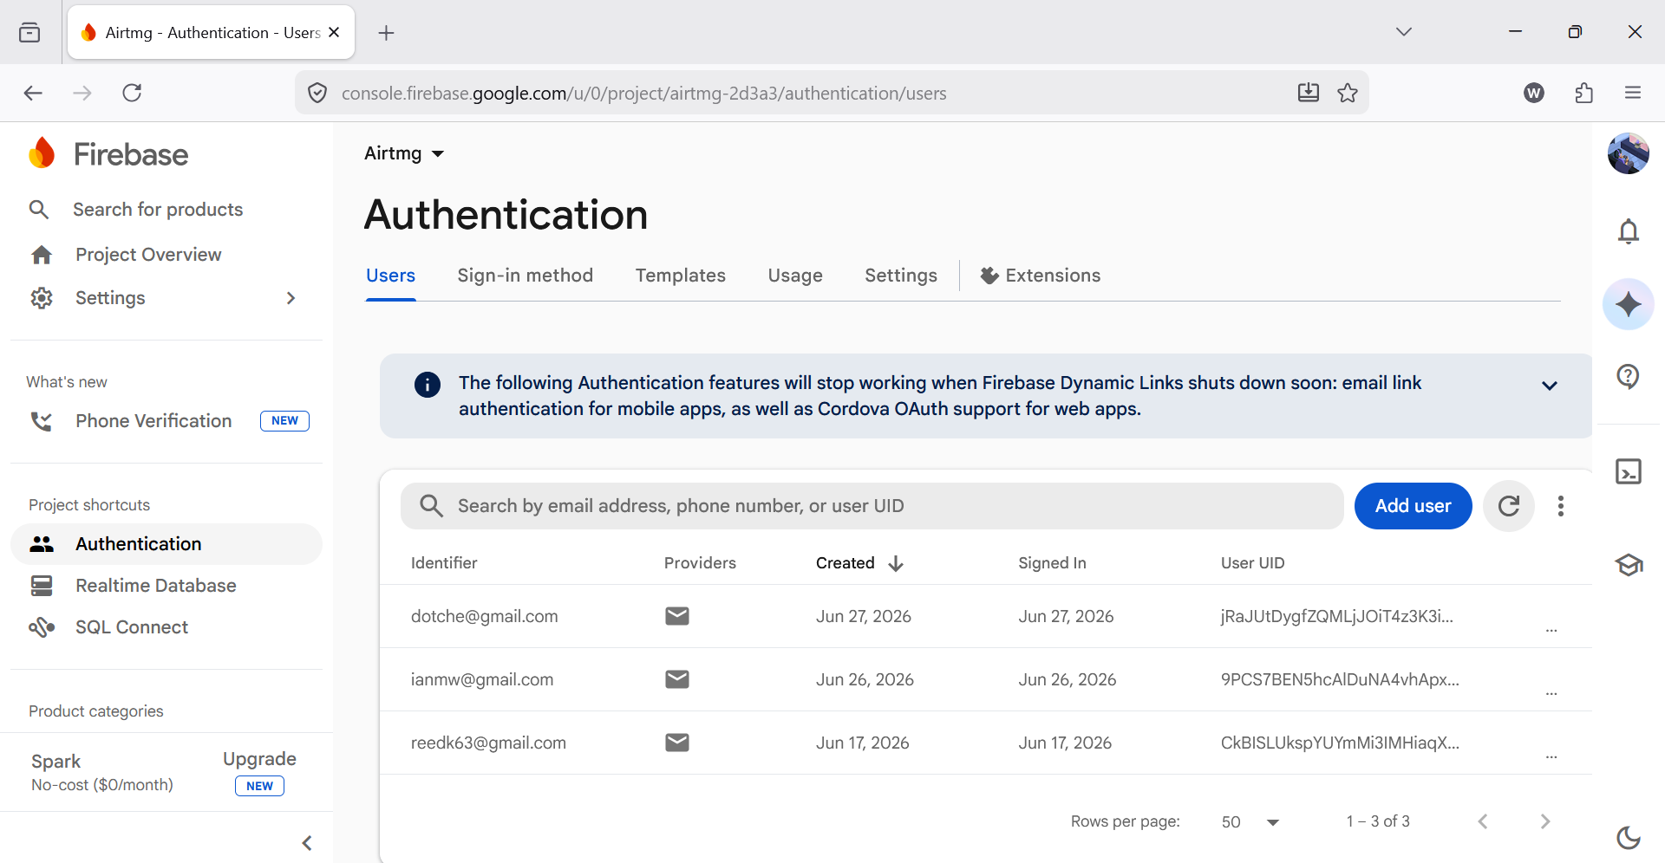
Firebase stores all login details.

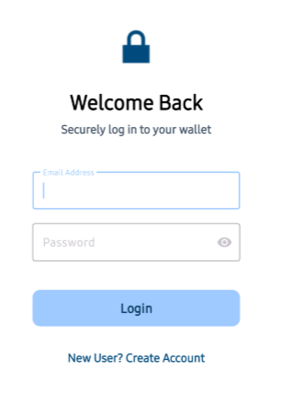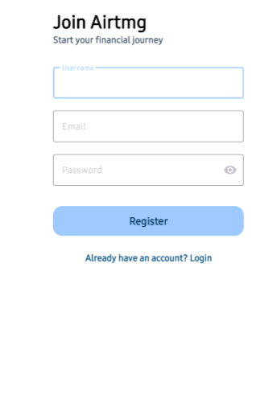
The two button use API’S end point to implicate post method(/login, /register)

Tools used:
-JSON
-Android studio

Personal reflection:
I learnt how mobile apps communicate external servers using APIs. I understood how data is fetched and displayed dynamically. I used firebase for authentication and database which acts like the back end exposing REST APIs that the app consumes. The API’S provide end points like post found in my login and registration pages are show in the screen shots above.
EXPLAIN WHY MY APPLICATION REQUIRE NETWORKING. (CLASS QUESTION)
Networking is essential in my cash transfer application because it enables the mobile app to communicate with remote servers over the internet. Without networking, users would not be able to send or receive money, access their account information, or perform transactions in real time.

Week 7: Application Architecture
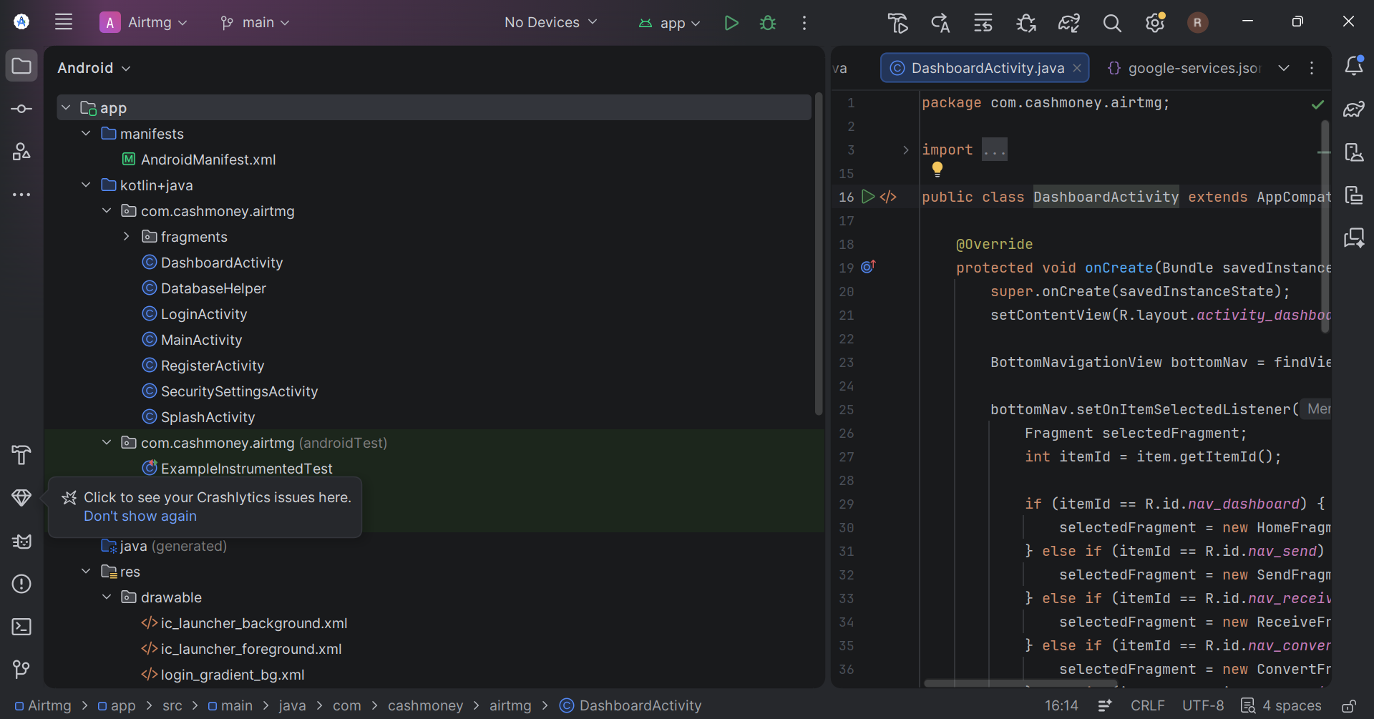

TOOLS USED
Android studio
Personal reflection
I translated theoretical ERD layout designs into a physical, multi-table SQLite relational database. Overriding standard factories with Web Assembly drivers to initialize these relational tables directly in the web browser console taught me how to manage robust data persistence across cross-platform web runtimes.

Week 8: Project Planning
Project planning is the process of defining a project's objectives, scope, tasks, resources, timeline, budget, and risks before development begins. It provides a clear roadmap for successfully completing the project.
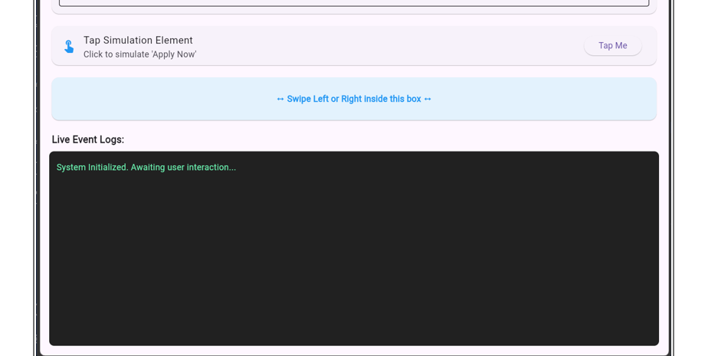

Tools used
Gesture detectors and input listeners
Event logging handlers
Android studio and simulation runtimes

Personal reflection
I explored interactive mobile design logic by implementing gesture detection and event logging. Mastering how runtime environments process user inputs and screen taps taught me how to bridge frontend interactive states with predictable backend control systems, making my application truly reactive

u

Week 9: Device Features and Sensors

Same as week 1

Week 10: Notifications and Background Services

Same as week 1

Week 11: Mobile Security

Same as week 1

Week 12: Testing and Debugging

Same as week 1

Week 13: Application Deployment

Same as week 1

Week 14: Final Project Presentation

Same as week 1

Semester Project Tracking

Project Title

Project Objectives

Project Requirements

Development Milestones

Testing Results

Lessons Learned

Future Improvements

End of Semester Reflection

Summary of Skills Acquired

Most Interesting Topic

Major Challenges Faced

How Challenges Were Overcome

Professional Growth Achieved

Overall Course Experience

Final Approval
Student Name: __________________________
Student Signature: ______________________
Date: _________________________________
Lecturer Name: _________________________
Lecturer Remarks: _____________________
Date: _________________________________

